Stepping Stones Adventure Preschool
Unlock Curiosity. Inspire Imagination

Parent Handbook

2025-2026

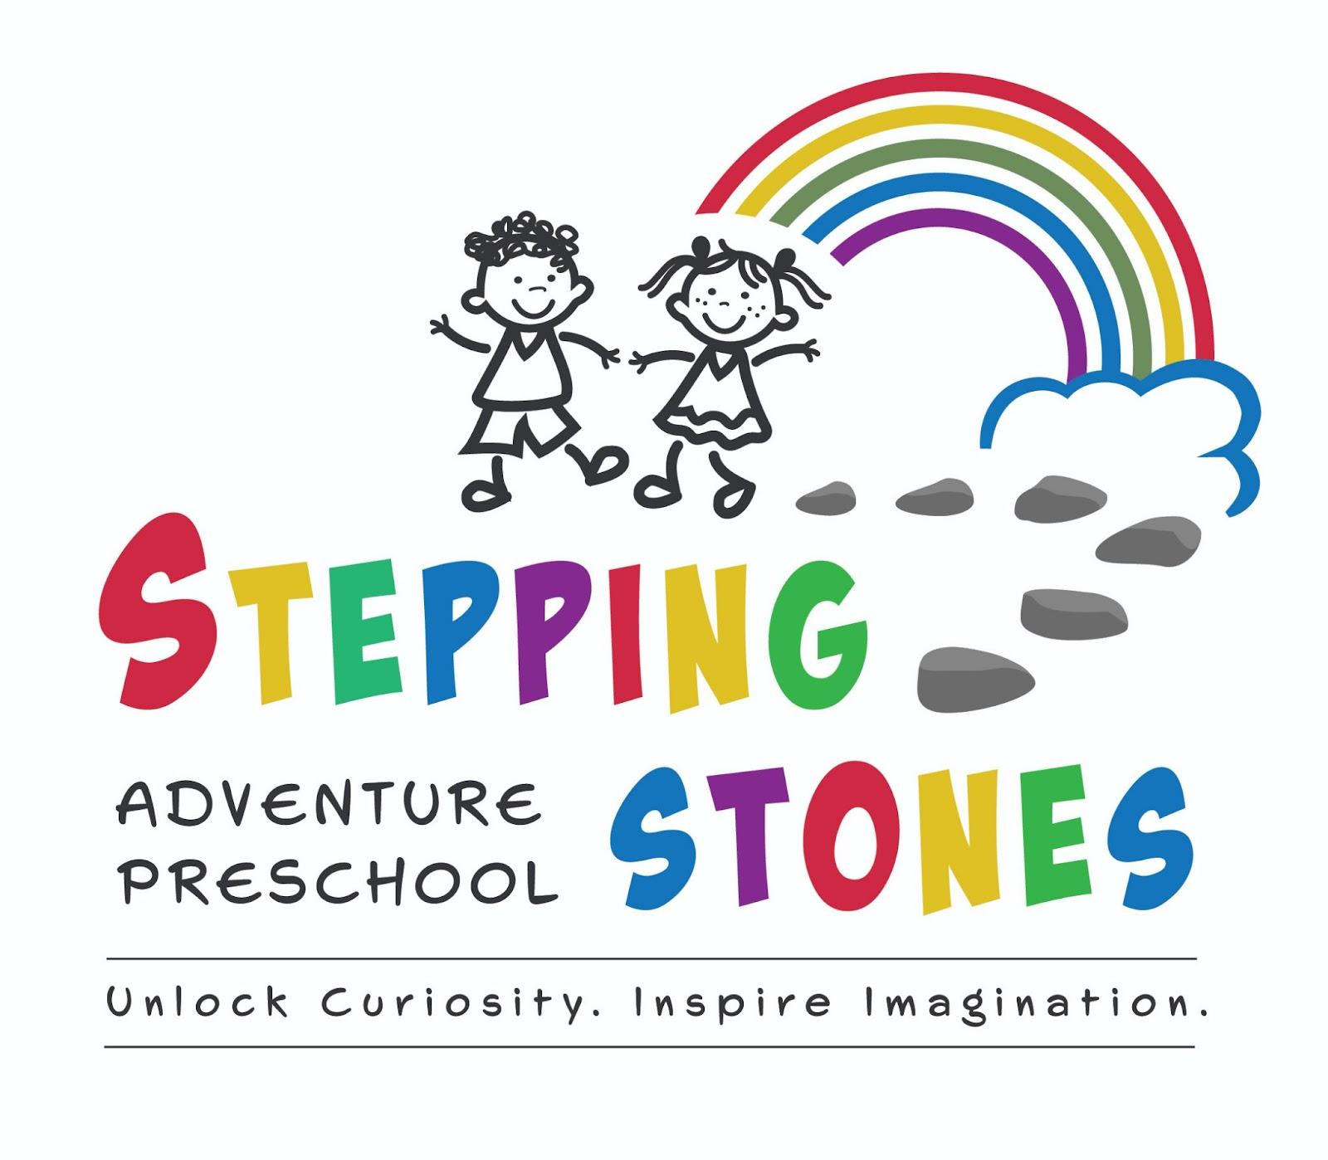

Table of Contents:
I. Welcome to Stepping Stones Adventure Pres-school
A. Mission
B. Core Values
C. Class Offerings
D. Operating Hours
E. Curriculum
II. Stepping Stones Adventure Preschool Community
A. New Student and Family Enrollment
B. Parent/Guardian Support
C. Fundraising
D. Community Support/Family Events
E. Finance (Tuition; Scholarships)
F. Withdrawing
III. Classroom Operations
A. Drop Off and Pick Up; Late Pick Up
B. Snacks/Lunch
C.Toileting
D. Personal Belongings
E. Communication
F. Celebrations (Birthdays; Cultural Events)
G. Media Usage
H.Safety
I.Mandatory Reporters
J. Animals
K. Handwashing
IV. Emergency Policies and Procedures
A. Injury/First Aid/Accident Report
B. Incident Report
C. Drills: Fire; Tornado; Other Threats
D. Severe Weather
V. Health/Medical
A. Health Screening
B. Physical Exam
C.Immunizations
D. Allergies
E. Medical Needs/Health Care Plan
F. Medication
G. Illness Policy

Welcome to Stepping Stones Adventure Preschool!

Welcome to the Stepping Stones Adventure Preschool Community! When your child enrolls at Stepping Stones Adventure Preschool, your whole family becomes a part of our community. We look forward to being a place where your child’s growth and development is nurtured, where you make lasting relationships with our teachers and other families, and where you feel supported in your parenting journey.

Mission

Stepping Stones Adventure Preschool is guided by the following mission statement: Our preschool provides a warm and nurturing environment where all children and families are an important part of our learning community. Our unique play-based program offers various activities that are specifically designed to encourage each child’s growth. Through cooperative play and creative activities, children reach their social, emotional and physical milestones naturally and with ease.

Core Values The following core values shape our community:

Inclusion:
Stepping Stones Adventure Preschool is a nurturing community where all students are welcome. The children learn in a play-based environment focused on social-emotional development, valuing each individual’s contribution, background, and circumstance. Children thrive with positive peer interactions and opportunities for authentic play. Children will be seen, known, and accepted for who they are.

Parent Cooperative Partnership:
Stepping Stones Adventure Preschool uses a team approach to
educate students ages 2.5-6 years old. Teachers and parent volunteers work together to meet children at their developmental level. In addition to classroom learning, children have the opportunity to participate in groups, guided by a teacher or parent, to target a specific developmental domain. Whether it is fine motor development, social emotional communication, large motor development, or school readiness, teachers and parent volunteers support the whole child in preparation for life. Parents are at the cornerstone of the child’s learning and Stepping Stones Adventure Preschool considers parents the child’s first and best teacher. Teachers have regular communication with parents and value this partnership.

Belonging:
Stepping Stones Adventure Preschool strives to have every child and family experience a sense of belonging. When families enter the building, they will feel love, acceptance, inclusion, compassion and support for their family’s life journey.

Class Offerings:

Stepping Stones Adventure Preschool is committed to an inclusive learning environment that adheres to a play-based approach. Through the collaboration of teachers, families and administrators, each child is nurtured in their development.

Stepping Stones Adventure Preschool believes that equal opportunity is important for the continuous success of the organization and strives to comply with applicable local, state, and federal laws which preclude discrimination because of race, disability, color, creed, religion, gender, age, sexual orientation, national origin, ancestry, citizenship, military status, or any other protected classification. This applies to all
activities of Stepping Stones Adventure Preschool, including but not limited to employment, selection of volunteers, purchasing, and selecting vendors or consultants.

Stepping Stones Adventure Preschool is licensed as a child care center by the Colorado Office of Early Childhood, Department of Human Services, and the Colorado State Department of Licensing. Parents have the right to file a complaint with the State Licensing Department. If a concern is not resolved at school, contact Colorado Department of Human Services, Office of Early Childhood, 1575 Sherman St., First Floor, Denver, Co. 80203-1714. Telephone (303) 866-5700.

Stepping Stones Adventure Preschool offers learning opportunities for children 2.5 years old through 6 years old. Class sizes and ratios will vary from one year to the next depending on the needs of our community.

Operating Hours:

Stepping Stones Adventure Preschool is open from 8:30 A.M. to 1:30 P.M. Monday through Friday.

We are closed on federal holidays and the following times throughout the year:

Monday through Friday of Thanksgiving week.
Winter Break (similar to the Jeffco public school winter break)
One week for Spring Break, typically in March.

As a licensed childcare center in the state of Colorado, staff are required to acquire a minimum of 15 hours of professional development each year. Staff also are trained in CPR and Standard Precautions. These trainings, as well as additional educational trainings may occur one or two days during the school year and will be listed on our school calendar as a staff training day and school will be closed that day.

All of our school closure dates are listed on the yearly school calendar which is available at the school and on our website.

Curriculum:
At Stepping Stones Adventure Preschool we offer a play based and developmentally appropriate curriculum that unlocks curiosity and inspires imagination. We offer a balance of child directed play and learning as well as teacher directed activities. Our curriculum emphasizes an integration of all areas of learning including social/emotional, cognitive, physical, and creative expression.

Teachers are trained in Pyramid Plus Positive Behavior Development and Conscious Discipline and teach children how to express and understand emotions. All cognitive subjects (Language and Literacy, Math, Science, and Social Studies) are taught through play and small and whole group learning using a hands on approach. We also supplement early literacy concepts using material from Handwriting Without Tears and Fundations. Large Motor instruction takes place every day through creative movement and music.

Becoming a part of the Stepping Stones Adventure Preschool Community:

New Student and Family Enrollment Tours are our first contact with new families. This tour is a way for families to see our school, ask questions, and learn about our philosophies. At the end of the tour, families are invited to complete an application packet and pay a one-time $200 non-refundable application fee. After the application fee is received, they are sent an electronic link to complete more of the enrollment paperwork.

Class Placement
After families have completed the electronic paperwork, families will receive an electronic confirmation, an invitation to accept or decline
the class placement, or request to stay on a waiting list. As families accept a placement, there is a $200 non-refundable registration fee.

Orientation
Prior to the beginning of school, families and students will be invited to Stepping Stones Adventure Preschool for an orientation day. On this day, they will see the classroom, meet the teachers, learn the drop-off routine, sign necessary paperwork, and meet administrators from the school.

Confidentiality
Stepping Stones Adventure Preschool respects the family's wishes regarding their child’s confidentiality. Parents will sign a form either giving SSAP permission to use their child’s photo in internal communication or to not use their child’s photo. This permission form will be sent to families electronically.

Parent/Guardian Support
In addition to providing optimal learning environments for preschool children, Stepping Stones Adventure Preschool is committed to the entire family. Parents/guardians are the child’s first and best teacher and SSAP desires a partnership that empowers parents in their role. Stepping Stones Adventure Preschool offers families the following:

Parent Teacher Conferences:
Two times each year, SSAP conducts parent/teacher conferences. At each conference, parents and teachers will discuss development, goals, and address any questions or concerns.
Parenting Classes:
Stepping Stones Adventure Preschool will offer parenting classes
a few times each school year covering a variety of topics including social emotional support, body safety, and supporting learning at home.
Weekly Newsletter:
SSAP sends a weekly newsletter on Friday afternoons to all families to keep them informed of school events, classroom learning and celebrations, and strengthen their knowledge of early childhood development.

Volunteer Opportunities:
Stepping Stones Adventure Preschool loves our parent volunteers and there are plenty of areas we can use your help. Classroom volunteers are needed daily, fundraising, and supporting our teachers and staff with small projects are just a few examples.

SSAP Social Gatherings:
Throughout the year, Stepping Stones Adventure Preschool will

organize social gatherings for current, incoming and alumni families. At these events, SSAP families are encouraged to build a community of support and friendship.

Fundraising
Because of Stepping Stones Adventure Preschool’s commitment to low teacher-student ratios, a highly qualified staff, and staff support through coaching and mentorship, SSAP relies on additional fundraising opportunities throughout the year to supplement the revenue provided by tuition. Tuition supplies SSAP with approximately 75-80% of its annual operating budget. The additional 20-25% of annual revenue comes from grants and fundraising events. All fundraising events will be listed on the school calendar, the Stepping Stones Adventure Preschool Facebook & Instagram pages, the
weekly newsletter, posters placed around the school, and flyers sent home to families. Families are invited and encouraged to volunteer in whatever capacity works for them.

Finance

Tuition:
Stepping Stones Adventure Preschool charges a monthly tuition which is collected September through May. Tuition is charged at the beginning of the month and can be paid online through the school’s website.

Fee Schedule:
Parents are expected to pay tuition by the 5th day of the month, after which a $25 late fee may be applied. Payments for tuition may be made through debit card, credit card, cash, Venmo, and PayPal. Any processing fees are paid by the family if they choose to pay with a credit or debit card.
2023-2024 Monthly Tuition

2 days 3 days 4 days Fridays
Half-Day  (8:30-11:30 am) | $225 | $325 | $425
Full Day  (8:30-1:30pm) | $470 | $570 | $670 | $180
*Tuition rates will vary based on UPK supported hours*

Scholarships:
Stepping Stones Adventure Preschool works with families needing tuition support as the school is committed to offering ALL children the opportunity to learn and grow at our school. Families may request a scholarship form at any time.

Withdrawing:
Families are asked to give Stepping Stones Adventure Preschool a 30-day notice before disenrolling from the school. The disenrollment form should be completed which will notify the school of the family’s intent. Before the child’s last day at SSAP, families will pay any outstanding balances to SSAP.

CLASSROOM OPERATIONS

Drop Off and Pick Up:
Drop off is at 8:30 am at which time you will sign your child in, help them hang their backpacks on their hook located on the outside of the classrooms, help them wash hands in our bathrooms located in our classrooms and then walk them to our playground to say your goodbyes or feel free to hang out for a bit as well! Pick up is at 1:30 pm on our playground. A staff member will meet you up front at 1:25pm to let you in the building. You will sign your child out where you signed them in at drop off.

At the end of the day, Stepping Stones Adventure Preschool will only release children to a designated pick-up person. Parents may designate other individuals as authorized for pick up and/or be an emergency contact for the child. If a person picking up the child is unknown to the Stepping Stones Adventure Preschool staff person, they will be asked to show identification and parents will be contacted.

Late Pick Up:
Stepping Stones Adventure Preschool requires parents to pick up children promptly in order to honor teachers and their family commitments. Parents are asked to call SSAP if they will be late. Families who chronically arrive late to pick up may be required to pay a late fee of $1/minute. If a family does not show up to pick up the child, SSAP will call the Department of Social Services and/or local law enforcement for help.

Snacks/Lunch:
Children will bring their own non-microwavable snacks to school. Students who stay for lunch will bring their own snack and their own non-microwavable lunch to school. Please pack an ice pack in your child’s lunch if it needs to remain cool. Stepping Stones Adventure Preschool is a nut-free school. Snacks and lunch sent to school must contain NO nuts, NO nut products, or NO nut butters. If there are not known nut allergies for any of our students or staff, SSAP may amend the nut free policy. Each classroom may have additional food restrictions (depending on food allergies in the classroom), and parents will be notified of any specific dietary restrictions in their child’s classroom. Any child who has a severe food allergy must have a written Allergy Health Care Plan signed by the parent and the child’s health care provider. The health care plan must be reviewed by the school nurse and emergency medication received BEFORE the student may start attending Stepping Stones Adventure Preschool.

Toileting:
Toilet training is encouraged unless there is a medical reason for the child’s inability to be toilet trained. Parents are asked to discuss their child’s individual toileting needs with the child’s teacher. We work hard to promote bathroom independence. Set your child up for success by sending them to school in clothing that they can manage on their own. Please reassure your child that although their teachers cannot wipe for them, as long as they try their best, you can help them once they get home.

Personal Belongings:
Students will bring a backpack large enough to hold artwork/projects and other supplies to school with their personal belongings. Each backpack should contain the following:

1. Change of clothes including socks and underwear in a labeled Ziplock bag
2. Labeled snack(s); labeled lunch (for students staying for lunch.)
3. Labeled water bottle
4. Labeled seasonally appropriate clothing: Mittens; Coat; Hat; Sunhat
5. Labeled sunscreen unless we can use our Babyganics to reapply

Steppings Stones Adventure Preschool will do everything to safeguard personal belongings, especially if the student brings an item for “Show and Share.” However, to assist the school, parents are asked to label
items with the child’s first and last name. Water bottles and food items MUST be labeled with the child’s first AND last name per licensing regulations. At Stepping Stones Adventure Preschool, students will be engaged in active learning, which means they may get messy inside the classroom and while playing outside. Parents are asked to dress their child appropriately for indoor play, outdoor play, and wear closed toed tennis shoes. Unless it is extremely cold outside, children will play outside for a portion of the time. Shoes for active play are encouraged. Any type of neckwear (necklaces, ties, scarves) is discouraged unless it can be easily removed to prevent a choking hazard.

Celebrations:
Families will communicate individually with the teachers regarding celebrations such as birthdays or cultural events. Stepping Stones Adventure Preschool will honor the demographics in the classroom in
planning activities that are inclusive to the beliefs of students.

Media Usage:
Stepping Stones Adventure Preschool believes that media time (i.e. “Screen Time”) should be very limited for children. This is also supported by the American Academy of Pediatrics as well as Child Care Licensing. We believe that it is better for children to be engaged in play activities rather than watching TV, DVD’s, playing computer games, etc. TV/DVD watching occurs only on rare occasions at SSAP when a media program is shown to enhance the educational curriculum.

Safety:
After a child is signed into the classroom, the child becomes the responsibility of Stepping Stones Adventure Preschool. Several
licensing requirements are put into place to ensure the safety of children while in our care. At every transition into or out of the classroom, teachers will perform headcounts to make sure all children are accounted for. Stepping Stones Adventure Preschool is committed to helping children feel emotionally safe. Students are taught to increase their “emotional vocabulary” by expressing their feelings through words.

Mandatory Reporters:
Stepping Stones Adventure Preschool staff members have the legal obligation to report any suspected cases of child abuse or neglect to the Department of Social Services or the local law enforcement agency. If parents have concerns regarding possible child abuse at our preschool, they should contact the Department of Social Services or the local law enforcement agency.

Animals:
Only service animals and classroom pets are allowed at Stepping Stones Adventure Preschool. No other animals should be brought into the school or be on the school grounds. Parents will be notified if a service animal will visit their child’s classroom, an animal presentation with live animals, or if there is a classroom pet in the classroom.

Handwashing:
Handwashing is a very important method for preventing the spread of disease. All students must wash their hands upon entering their classroom, before and after eating, after using the restroom, and before and after sensory table play. Teaching the proper handwashing technique is an important part of the classroom curriculum.

EMERGENCY POLICIES AND PROCEDURES

Injury/First Aid/Accident Report:
All staff are trained in basic first aid and CPR. If a child is injured or becomes seriously ill, staff will provide care as indicated. For emergency situations, 911 will be called, and parents will also be notified. In the event of an accident, an accident/injury report form will be completed. The form reports: child’s name, address, parent’s name, date, time, the how, when, where of the accident, how the child was assisted, names (and signatures) of adults, witnesses on duty, and the time the parent was notified.

Incident Report:
If a behavioral “incident” occurs at school (such as biting or hitting), teachers will document the behavior on a behavior incident form. This
serves as a way to inform the parents/caregivers of the incident, and
will also allow Stepping Stones Adventure Preschool to collect data on the behavior.

Fire Drills; Other Threats:
Stepping Stones Adventure Preschool takes children’s safety seriously and will teach children about keeping themselves safe in the case of natural disasters and human threats. The following drills occur at the school each year:

Fire Drill: Monthly

Human or Other Environmental Threat Drill: At least two times each year for the following:

Lock Down: Threat is inside the building. Children will participate in the lock down drills that we refer to as “safety drills”. Staff and students will practice Lock Down, “safety”, drills quarterly.

Shelter-In-Place: Threat posed by atmospheric contamination, chemical, biological or radiological hazards. Communicated through the tornado horn.

Lock Out: Threat on the outside of the building. All doors will be locked and no one will be permitted to enter the building. Classrooms will continue as normal.

Parent Reunification:
Should evacuation be needed away from school grounds, children will walk with SSAP staff to Walgreens located at 12880 W Alameda Pkwy, Lakewood, CO 80228 and parents will be called.

Severe Weather:
Occasionally, Stepping Stones Adventure Preschool will need to close for severe winter weather conditions. While SSAP can make its own decision regarding closure, Stepping Stones Adventure Preschool is guided in its decision-making process by the decisions of Jeffco Public Schools. If it is deemed unsafe for parents to drive their children to school, or for staff to safely get to school, SSAP will be closed.
Stepping Stones Adventure Preschool will notify families about school closures via e-mail, text, and our social media pages.

Tornado
If tornado sirens sound while children are at Stepping Stones Adventure Preschool, the children will be taken to an inner room (Sunshine room) and kept safe until the local authorities deem the area to be safe from the threat of a tornado.

Natural Disaster
Other natural disasters, such as floods and extreme heat, are unlikely at Stepping Stones Adventure Preschool because of the school’s geography. If either were to occur while children are at SSAP, parents would be notified by text, email and phone.

HEALTH/MEDICAL

Health Screening:
Health screening and preventive health care are important to identify health problems even before symptoms may be present. In addition to yearly well child checks, it is recommended that preschool age children receive annual hearing, vision and dental screenings.

Physical Exam:
Before a student can start attending Stepping Stones Adventure Preschool parents must submit a Physical Exam Form, completed and signed by the student’s health care provider. This form can be a SSAP Physical Exam Form OR a similar physical exam form/health statement that is used by the health care provider. State regulations require that the physical exam statement must be signed and dated by a health care provider who has seen the child within the last 12 months. The form must indicate when the next visit is required by the health care provider. An updated physical exam form is also required within 30 days after the expiration date of the previous physical exam (usually 1 year) OR sooner if the health care provider has requested this. Parents are responsible for submitting this updated form to Stepping Stones Adventure Preschool. Please inform the school if anything changes regarding your child’s health status during the year.

Immunizations:
While the state of Colorado does not require children to be immunized to attend childcare or school, Stepping Stones Adventure Preschool encourages all students to be fully immunized as this will help keep all students and staff healthy.

Allergies:
Parents are asked to report to Stepping Stones Adventure Preschool and to the child’s teacher if the child has any allergies. Since students attending SSAP have severe nut allergies, no nuts or nut products are allowed in the school at any time. Students who have a severe allergy that may require the administration of medication for a severe allergic reaction will need to have a Health Care Plan and medication in place BEFORE the student starts attending.

Medical Needs/Health Care Plan:
If a student has significant medical needs, the parent must provide Stepping Stones Adventure Preschool with an individualized Health Care Plan. The plan must be signed by the child’s health care provider and must be in place BEFORE the student starts attending school at SSAP. Stepping Stones Adventure Preschool does not employ a full time medical provider on site. Our preschool area nurse will train staff, in coordination with the parent, in order to be able to carry out the health care plan. The Health Care Plan must be updated annually. If the Health Care Plan has expired, students will not be allowed to attend school until an updated and signed plan is received.

Medication:
In order to assure that medications are given safely and appropriately, no medication can be accepted at Stepping Stones Adventure Preschool or administered to a student until a medication consent
form is completed and signed by the parent/guardian AND the student’s Health Care Provider. This includes both prescription medication AND over the counter medication (eg Tylenol, Advil, Benadryl). If a student needs to have medication kept at school to be given in case of a medical emergency (eg epi pen, inhaler, Diastat, glucagon), the student will NOT be able to start attending Stepping Stones Adventure Preschool until a Health Care Plan/Medication Consent has been completed/signed AND the medication is received at school.

Medications are stored, administered, and delegated to staff for administration by our part time area nurse in compliance with the Colorado Nurse Practice Act. Medications are kept in a cabinet in our office away from children but accessible to staff as needed. A Medication Log is kept for all students who have medication
administered at Stepping Stones Adventure Preschool. The following
forms related to medication consent are available in our office and electronically: 1) Severe Allergy Emergency Care Plan/Medication Consent; 2) Asthma Care Plan/Medication Consent; 3) Seizure Action Plan/Medication Consent; 4) Medication Consent Form (for other medications).

Medication Consent Forms must be updated annually. It is the responsibility of the parent to note the expiration date of medication sent to school and replace it before the expiration date. Once a replacement medication is brought to school, parents should take home the expired medication. If the medication consent form has expired or the medication has expired, students will not be allowed to attend school until an updated/signed medication consent form and replacement medication is received. If a student needs medication kept/given at Stepping Stones Adventure Preschool, parents must read the school’s Medication Policy so that they are aware of the requirements. This policy is on the school’s website or is available in the office. If a student is taking medications at home, Stepping Stones Adventure Preschool requests that teachers be informed so they are aware of any side effects.

Illness Policy:
Stepping Stones Adventure Preschool has a responsibility to create a safe and healthy environment for all children and staff members. The state of Colorado has strict licensing requirements on the frequency of handwashing, disinfecting, and sanitizing. Children, however, learn in community and in close proximity to one another. Since young children have had less time for exposure to viruses, they tend to get sick more frequently as their bodies develop antibodies. Stepping Stones Adventure Preschool follows recommendations from The
Colorado Department of Public Health and Environment “How Sick is too Sick” when students/staff should not attend school because of illness. Please do not send your child to school if they have any illness symptoms and notify the school by email, text, or phone.

Child Becomes Ill at School:
If a child develops illness symptoms while at school or is not able to participate in daily activities, the parent/guardian/emergency contact will be notified. The child will be removed from the classroom and will wait in a supervised “sick area” until a parent/guardian or emergency contact can pick up the child. Parents/guardians are asked to make sure either they or an emergency contact is available by phone during the school day and is within about a 20 minute drive from the school in case the student needs to leave school for illness, injury, or other emergency.

